CONVENTIONAL GRADES
M2 HIGH SPEED STEEL

CHEMICAL COMPOSITION
c | Cr | Mo | W | Co | V
0.90* | 4.2 | 5.0 | 6.4 | - | 1.8

*0.85 for strips

STANDARDS
r~USA:AISI M2
- Europe: HS 6-5-2
- Germany: W.Nr. 1.3343
- France: (AFNOR Z85WDCV6.5.4.2)
- Sweden: SS 2722
- UK: BM2
- Japan: JIS SKH51

DELIVERY HARDNESS
Soft annealed max. 260 HB
Cold drawn max. 310 HB
Cold rolled max. 310 HB

DESCRIPTION
E M2 is a medium-alloyed high speed steel which has a good machinability and a good performance and is used in a wide variety of applications.

APPLICATIONS

HEAT TREATMENT
- Soft annealing in a protective atmosphere at 850- 900°C for 3 hours, followed by slow cooling 1O°C per hour down to 700°C, then air cooling.
- Stress-relieving at 600°C to 700°C for approximately 2 hours, slow cooling down to 500°C.
- Hardening in a protective atmosphere with preheating in 2 steps at 450-500°C and 850-900°C and austenitizing at a temperature suitable for chosen working hardness.
- 2 tempers at 560°C are recommended with at least 1 hour holding time each time.
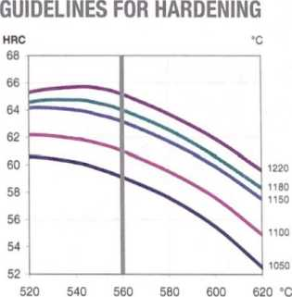
Tempering Temperature in °C
Hardness after hardening, quenching and tempering 2 x 1 hour
・ Twist drills | • Broaches
• Reamers | ・ Knives
• Milling cutters | • Saws
• Taps & dies | • Cold work tools
FORM SUPPLIED
• Drawn wire | ・ Strips
• Wire rod | • Sheets
♦ Round bars | • Discs
• Flat bars | • Bi-metal edges
• Square bars
Available surface conditions: drawn, ground, hot rolled, cold rolled, peeled, turned.
Tool | Hardening | Tempering
Single-edge cutting tools | 1220°C | 560°C
Multi-edge cutting tools | 1180-1220°C | 560°C
Cold work tools | 1100-1150°C | 560°C

 | AoDroximate Conversion
°C | 20 | 25 | 400 | 450 | 500 | 520 | 540 | 560 | 600 | 620 | 700 | 800 | 850 | 900
°F | 70 | 80 | 750 | 840 | 930 | 970 | 1000 | 1040 | 1110 | 1150 | 1290 | 1470 | □560 | | 1650~1

PROCESSING
E M2 can be worked as follows:
- machining (grinding, turning, milling)
- polishing
- plastic forming
- electrical discharge machining
- *?lding (special procedure including preheating and filler materials of base material composition)

GRINDING
During grinding, local heating of the surface, which can alter the temper, must be avoided. Grinding wheel manufacturers can give some advice on the choice of grinding wheels.

SURFACE TREATMENT
The steel grade is a good substrate material for PVD and CVD coating. If nitriding is requested a small zone of 2-15 pm is recommended. The steel grade can also be steam-tempered if so desired.
PROPERTIES

material safety data sheet
 | Temperature
 | 20°C | 400。。 | 600°C |
Density g /cm³ (1) | 8.1 | 8.1 | 8.0
Modulus of elasticity kN/mm² (2) | 225 | 200 | 180
Thermal expansion ratio per °C (2) | - | 12.1x1 O'⁶ | 12.6x10
Thermal conductivity  W/m°C (2) | 24 | 28 | 27
Specific heat J/kg °C (2) | 420 | 510 | 600

PHYSICAL PROPERTIES
⑴ Soft annealed
⑵ Hardened 1180°C and tempered 560°C, 3x 1 hour
Rmb = Ultimate bend strength in kN/mm² Reb = Bend yield strength in kN/mm² Tot. work = Total work in Nm
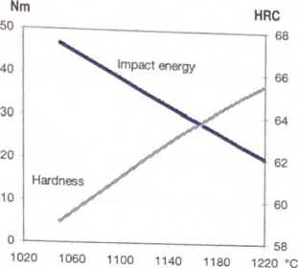
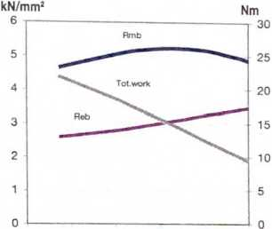
MSDS:A
IMPACT strength
Hardening Temperature in °C
Tempering 2 x 1 hour at 560° C
Unnotched test piece 7x10x55 mm
POINT BEND STRENGTH
1020 1060 1100 1140 1180 1220 °C
Hardening Temperature in °C
Tempering 2 x 1 hour at 560° C
Unnotched test piece 04.7 mm

