CONVENTIONAL GRADES

M35 HIGH SPEED STEEL

Tempering Temperature in °C
Hardness after hardening, quenching and tempering 2 x 1 hour

CHEMICAL COMPOSITION
C | Cr | Mo | W | Co | V
0.93 | 4.2 | 5.0 | 6.4 | 4.8 | 1.8

STANDARDS
- USA:AISI M35
- Europe: HS 6-5-2-5
- Germany: W.Nr. 1.3243
- France: (AFNOR Z90WDKCV6.5.5.4.2)
- UK: BM35
- Janpan: JIS SKH55

DELIVERY HARDNESS
Soft annealed max, 270 HB
Cold drawn max, 320 HB
Cold rolled max, 320 HB

DESCRIPTION
M35 contains Cobalt for increased hot hardness. The composition of E M35 offers a good combination of toughness and hardness. E M35 has a good machi-nability.

APPLICATIONS
- Reamers
- Hobs
- Broaches
- Saws
- Cold work
- Milling cutters
- End mills
- Cutters

HEAT TREATMENT
- Soft annealing in a protective atmosphere at 850- 900°C for 3 hours, followed by slow cooling 1O°C per hour down to 700°C, then air cooling.
- Stress-relieving at 600°C to 700°C for approximately 2 hours, slow cooling down to 500°C.
- Hardening in a protective atmosphere with pre-heating in 2 steps at 450-500°C and 850-900°C and austenitizing at a temperature suitable for chosen working hardness.
- 2 tempers at 560°C are recommended with at least 1 hour holding time each time.
GUIDELINES FOR HARDENING
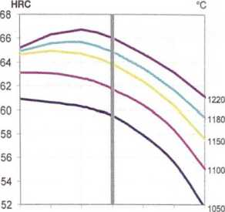
500 520 540 560 580 600 620°C
Tool | Hardening | Tempering
Single-edge cutting tools | 1220°C | 560°C
Multi-edge cutting tools | 1180-1220°C | 550-570°C
Cold work tools | 1050-1150°C | 550-570°C
Available surface conditions: drawn, ground, rolled, hot rolled, cold rolled, peeled, turned.
- Square bars
- Strips
- Sheets
- Discs
- Wire rod
- Drawn wire
- Round bars
- Flat bars
FORM SUPPLIED
Approximate Conversion
°C | 20 | 25 | 400 | 450 | 500 | 520 | 540 | 560 | 600 | 620 | 700 | 800 | 850 | 900
°F | 70 | 80 | 750 | 840 | 930 | 970 | 1000 | 1040 | 1110 | 1150 | 1290 | 1470 | 1560 | 1650

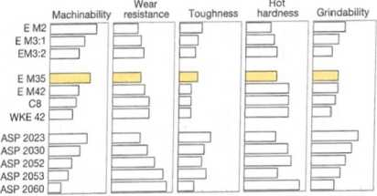
PROCESSING
E M35 can be worked as follows:
- machining (grinding, turning, milling)
- polishing
- plastic forming
- electrical discharge machining
。welding (special procedure including preheating and filler materials of base material composition)

GRINDING
During grinding, local heating of the surface, which can alter the temper, must be avoided. Grinding wheel manufacturers can give some advice on the choice of grinding wheels.

SURFACE TREATMENT
The steel grade is a good substrate material for PVD and CVD coating. If nitriding is requested a small zone of 2-15 pm is recommended. The steel grade can also be steam-tempered if so desired.
PROPERTIES

PHYSICAL PROPERTIES
 | 20°C | Temperature  400°C 600°C
Density g/cm³ ⑴ | 8.1 | 8.0 | 8.0
Modulus of elasticity KN/mm² (2) | 230 | 205 | 184
Thermal expansion ratio°C(2)  严「弋(2) | - | 11.6x10 | 11.9x1 O⁶
Thermal conductivity  W/m°C(2) | 24 | 28 | 27
Specific heat J/kg °C (2) | 420 | 510 | 600
(1) Soft annealed
⑵ Hardened 1180°C and tempered 560°C, 3 x 1 hour

MATERIAL SAFETY DATA SHEET
MSDS: B

IMPACT STRENGTH
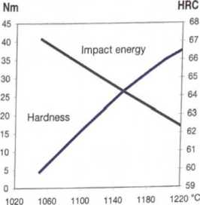
Hardening Temperature in °C
Tempering 2 x1 hour at 560° C
Unnotched test piece 7x10x55 mm

POINT BEND STRENGTH
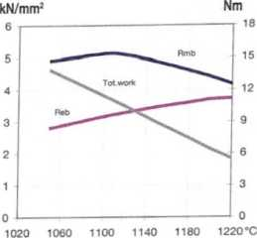

Hardening Temperature in °C
Tempering 2 x 1 hour at 560° C
Unnotched test piece 04.7 mm
Rmb = Ultimate bend strength in kN/mm² Reb = Bend yield strength in kN/mm² Tot. work = Total work in Nm

COMPARATIVE PROPERTIES

